**Portfolio Construction:**

Portfolio construction is simply selecting a ‘basket’ of investments – selected from available investment types such as cash, fixed interest, property, equities (shares) and even alternative investments – that consider the investor’s objectives over the short, medium and/or long term.

**It is about constructing a diversified portfolio of assets using an appropriate asset allocation strategy to enhance performance and minimise risk of the overall portfolio (or basket of investments).**

Using a risk reward concept, a general framework can be drawn that any investor can use to assess his or her personal risk level and how this level relates to different investments.

For investment securities, we can create a chart with the different types of securities and their associated risk/reward profiles like below…just a guideline:

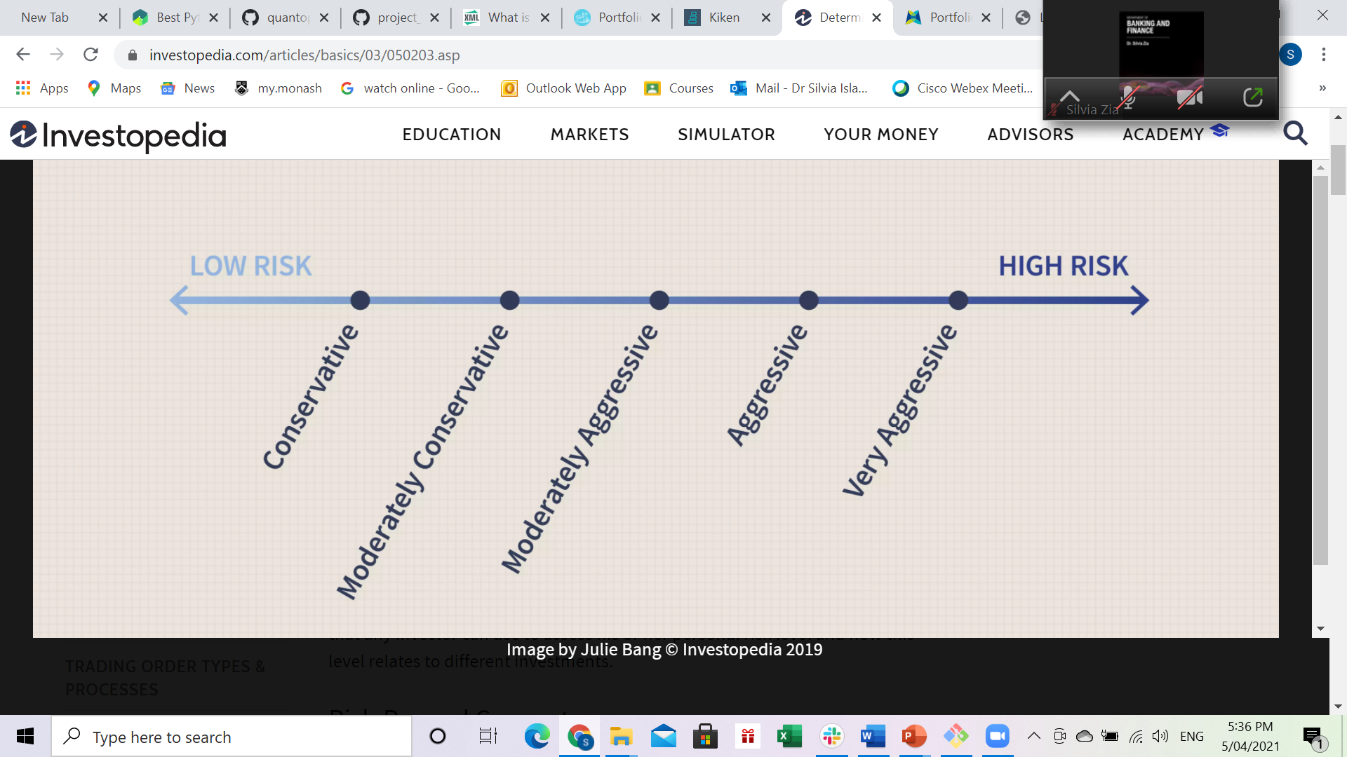

**Determining Your Risk Preference**

With so many different types of investments to choose from, how does an investor determine how much risk he or she can handle? Every individual is different, and it's hard to create a steadfast model applicable to everyone, but here are two important things you should consider when deciding how much risk to take:

**Time Horizon:** Before you make any investment, you should always determine the amount of time you have to keep your money invested. If you have $20,000 to invest today but need it in one year for a down payment on a new house, investing the money in higher-risk stocks is not the best strategy. The riskier an investment is, the greater its volatility or price fluctuations. So, if your time horizon is relatively short, you may be forced to sell your securities at a significant loss. With a longer time, horizon, investors have more time to recoup any possible losses and are therefore theoretically more tolerant of higher risks. For example, if that $20,000 is meant for a lakeside cottage that you are planning to buy in 10 years, you can invest the money into higher-risk stocks. Why? Because there is more time available to recover any losses and less likelihood of being forced to sell out of the position too early.

**Bankroll:** Determining the amount of money you can stand to lose is another important factor in figuring out your risk tolerance. This might not be the most optimistic method of investing; however, it is the most realistic. By investing only money that you can afford to lose or afford to have tied up for some period of time, you will not be pressured to sell off any investments because of panic or liquidity issues. The more money you have, the more risk you are able to take. Compare, for instance, a person who has a net worth of $50,000 to another person who has a net worth of $5 million. If both invest $25,000 of their net worth into securities, the person with the lower net worth will be more affected by a decline than the person with the higher net worth.

**KEY STEPS TO PORTFOLIO CONSTRUCTION:**

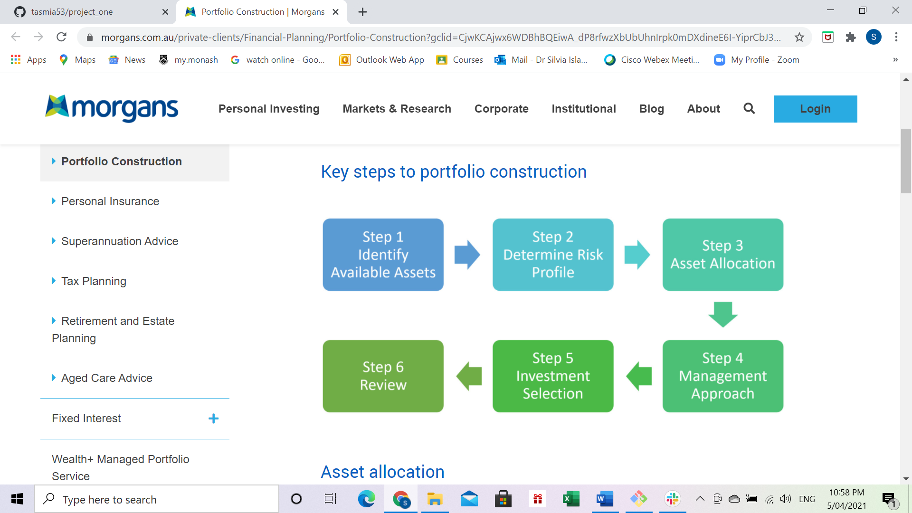

Asset allocation

Asset allocation is a key fundamental of portfolio construction and investing. Studies have shown that a large part of the variation in returns between different portfolios can be attributed to inappropriate allocation of assets, rather than market timing or individual investment selection.

There are four types of asset allocation methods used in the industry.

1. Static – set the benchmark and hold
2. Strategic – set the benchmark, regularly review and re-balance when required
3. Tactical – short term tactical changes to "beat the market"
4. Dynamic – based on macro trends, economic cycles, etc

Fundamentals of asset allocation

1. Diversification
2. Defensive assets vs Growth assets
3. Time frame for investing
4. Rebalancing the portfolio

Successful asset allocation means achieving objectives with the least possible risk.

Some fundamentals about Portfolio Theory:

**Following Markowitz Portfolio Theory: Efficient set theorem**

* Based on these assumptions the solution to the basic problem of selecting an optimal portfolio is given by the efficient set theorem.
* Investors will choose the optimal portfolio from the set of portfolios that

**1. Maximize expected return for a given level of risk**

**AND/OR**

**2. Minimize risks for a given level of expected returns**

**Expected Rates of Return**

* The expected rate of return for a portfolio of investment is simply the weighted average of the expected return for each asset/investment comprising the portfolio.
* The weights are the proportion of total values for the individual investment. For example, W1+ W2 = 1

E(Rp)= W1 x E(R1 )+ W2 x E(R2 )

**Expected Risk of the Portfolio**

* When two risky assets with variances s12 and s22, respectively, are combined into a portfolio with portfolio weights of w1 and w2, respectively, the portfolio variance is given by:

σp2= W12σ12 + W22σ22 + 2W1W2 Cov(r1r2)

Here, Cov(r1,r2) = Covariance of returns for asset 1 & 2

**Efficient Frontier:** Use the Markowitz portfolio theory to plot the risk-return combination in the graph to separate the efficient portion.

**Beta:   
A measure of (sensitivity to) market risk**

A measure of: How an individual share’s returns vary with market returns. The “sensitivity” of an individual share’s returns to changes in the market.

For the market: Beta = 1

A firm with Beta =1 has average market risk. It has the same volatility as the market.

A firm with Beta > 1 is more volatile than the market.

A firm with Beta < 1 is less volatile than the market.

Based on the risk preference questionnaire we have assigned the weights to different risk profile group:

p1= desc="A preservation portfolio is most appropriate for those that are in retirement, very low tolerance for risk and/or looking for consistent monthly interest. This portfolio is 100% weighted towards fixed income."

Stable Dividend growth company – 20% T-Bill (Govt. Bonds) – 80%

p2 = desc="A conservative portfolio is most appropriate for those with short time horizons, close to retirement, or low tolerance for risk. This portfolio is weighted towards fixed income."

Stable Dividend growth company – 35%; T-Bill (Govt. Bonds) – 65%

p3 = desc="A balanced portfolio is most appropriate for those with medium time horizons and moderate risk tolerance. This portfolio is balanced between equity and fixed income"

Stable Dividend Company – 20%; Growing company – 40%; T-Bill (Govt. Bonds) – 40%

p4 = desc="A aggressive portfolio is most appropriate for those with longer time horizons, young in age, and a higher risk tolerance."

Stable Dividend company – 10%; Crypto – growth shares – 20%; High risk company based on Sharpe Ratio – 65%; (T-Bill (Govt. Bonds) – 5%

p5 = desc="A all equity portfolio is most appropriate for those with longer time horizons, young in age, higher risk tolerance and high capacity to take risk. This portfolio is 100% weighted towards equity"

Crypto – growth shares – 45%; High risk company based on Sharpe Ratio – 50%; (T-Bill (Govt. Bonds) – 5%

We have our weights; we have our risk preference calculation.

Based on the dividend growth rate you can choose the best one: Criteria for selecting top ranking ones for each of the above.

Disclaimer: 1. Dividend reinvestment not considered

2. Fees and Transaction costs not considered